Worksheet 2.1

Student Name: Sahil Kaundal UID: 21BCS8197

Branch: CSE (Lateral Entry) Section/Group:20BCS-807_B Semester: 4th Date of Performance: 09/03/2022

Subject Name: SE Lab Subject Code: 20CSP-255

Q1.

1. Aim/Overview of the practical:

Construct an E-R diagram for a car-insurance company whose customers own one or more cars each. Each car has associated with it zero to any number of recorded accidents.

1. Task to be done/ Objective:



* The objective of Data Flow Diagram (DFD) is to graphically represent flow of data in an information system.
* It is capable of depicting incoming data flow, outgoing data flow and stored data.
* Car insurance company is a software system that can store, update, and retrieve the information through Databases.

1. Requirement Analysis:

Software Requirement:

* Smart Draw
* Google Chrome

Hardware Requirement:

* Computer
* Windows 10
* Power Supply

1. DATA FLOW DIAGRAM (DFD):

Data flow diagram is graphical representation of flow of data in an information system. The DFD does not mention anything about how data flows through the system. It is capable of depicting incoming data flow, outgoing data flow and stored data.

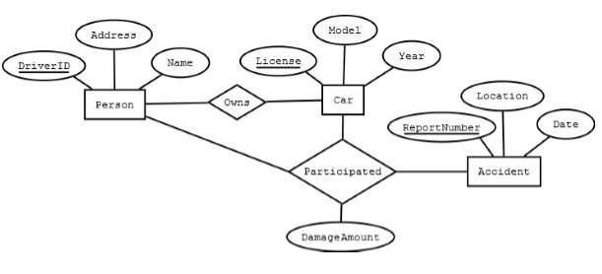

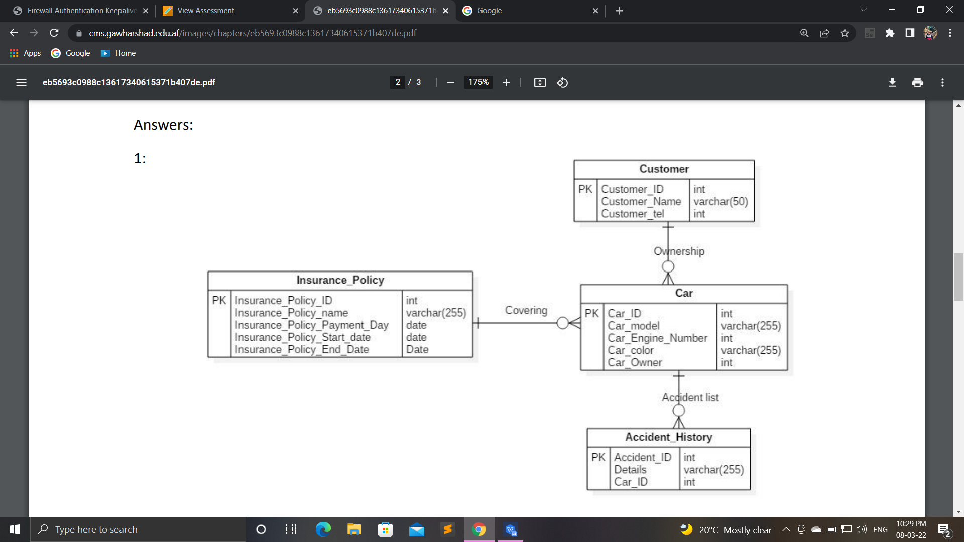

Q2.

1. Aim/Overview of the practical:

A university registrar’s office maintains data about the following entities:

1. courses, including number, title, credits, syllabus, and prerequisites;
2. course offerings, including course number, year, semester, section number, instructor(s), timings, and classroom;
3. students, including student-id, name, and program;
4. instructors, including identification number, name, department, and title. Further, the enrolment of students in courses and grades awarded to students in each course they are enrolled for must be appropriately modelled. Construct an E-R diagram for the registrar’s office. Document all assumptions that you make about the mapping constraints.
5. Entity Sets:



* ****Students----** sid, name, program**
* ****Instructor---** id, name, dept, title**
* ****Course---** syllabus, course_no, title, credits, prerequisities**
* ****Course-offering---** sec_no, year, semester, time, room**

1. Relationship Sets:

Enrols--- Each student can enroll in several courses, grade must be kept

Relationship attribute--- Grade

Teaches--- An instructor can teach several sections

Is-offered--- multiple sections of a course may be offered

Requires--- Prerequisite, main_course

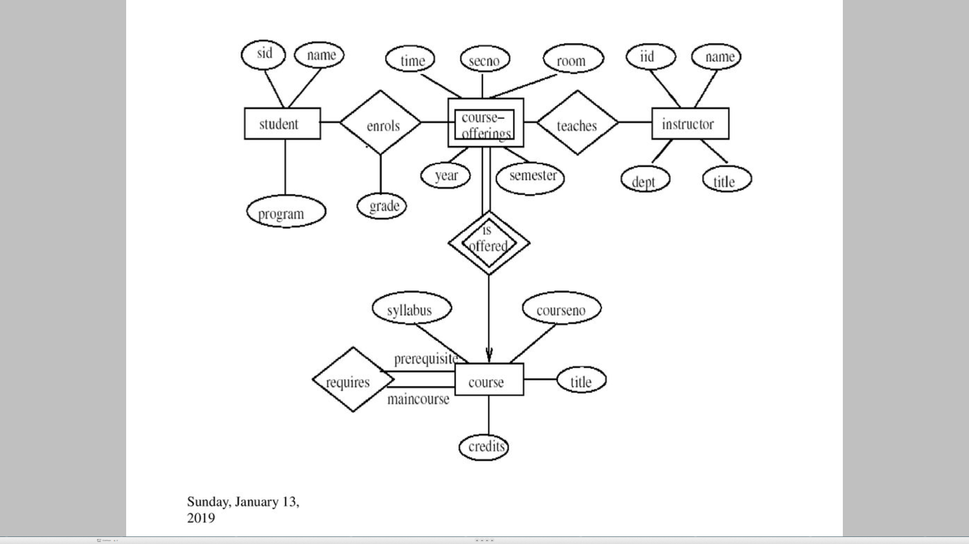

1. Reducing the ER diagram to tables:

*Entities*

*Student table*

|  |  |  |
| --- | --- | --- |
| Sid | Name | Program |

*Course*

|  |  |  |  |
| --- | --- | --- | --- |
| Course_no | Title | Syllabus | Credits |

*Instructor*

|  |  |  |  |
| --- | --- | --- | --- |
| ID | Name | Dept | Title |

*Course Offerings*

|  |  |  |  |  |  |
| --- | --- | --- | --- | --- | --- |
| Course_no | Sec_no | Year | Semester | Time | Room |

1. Relationships:

*Enrolls*

|  |  |  |  |  |  |
| --- | --- | --- | --- | --- | --- |
| Sid | Course_no | Sec_no | Semester | Year | Grade |

*Teaches*

|  |  |  |  |  |
| --- | --- | --- | --- | --- |
| Course_no | Sec_no | Semester | Year | IID |

*Requires*

|  |  |
| --- | --- |
| Main_course | Prerequisite |

1. Result/Output/Writing Summary:

I have successfully done this practical.

Learning outcomes (What I have learnt):

1. Learned about ER Diagram.
2. Learned about Entity Set.
3. Learned about Relationship Set.

Evaluation Grid (To be created as per the SOP and Assessment guidelines by the faculty):



|  |  |  |  |
| --- | --- | --- | --- |
| Sr. No. | Parameters | Marks Obtained | Maximum Marks |
| 1. |  |  |  |
| 2. |  |  |  |
| 3. |  |  |  |
|  |  |  |  |